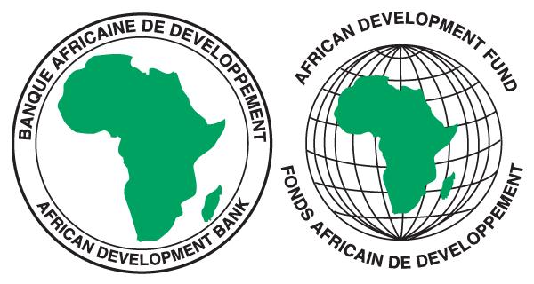


SOUTHERN AFRICAN DEVELOPMENT COMMUNITY (SADC) SECRETARIAT

REQUEST FOR EXPRESSIONS OF INTEREST

JOB TITLE: PROJECT COORDINATOR (Individual Consultant)
REFERENCE No. SADC/3/5/2/435

PROJECT: RESILIENT HEALTH SYSTEMS AND EMERGENCY PREPREDNESS

FINANCING AGREEMENT REFERENCE: TBA

PROJECT ID NO.: P-Z1-IB0-043

DATE: 2nd April 2026
- The Southern African Development Community (SADC) Secretariat has applied for financing from the African Development Fund towards the cost of the RESILIENT HEALTH SYSTEMS AND EMERGENCY PREPREDNESS PROJECT and intends to apply part of the agreed amount for this grant to payments under the contract for a Project Coordinator.

- As part of the implementation of the Project, SADC Secretariat is recruiting a Project Coordinator. SADC Secretariat hereby invites Individual Consultants to indicate their interest in the assignment.

- Objective of the assignment:

The Project Coordinator shall coordinate and manage the implementation of the Resilient Health Systems and Emergency Preparedness Project. This will include providing operational oversight, financial management, procurement, reporting and communication with the SADC Secretariat and the African Development Bank.

- Scope of Work

The scope of work of the Project Coordinator will include but not limited to the following: manage the project throughout its lifecycle, strategically and effectively manage all resources of the project, provide overall leadership and technical guidance, and ensure quality and timely achievement of project deliverables. The detailed scope of work is contained in the TORs which can be accessed through the link: https://www.sadc.int/procurement-opportunities

- Duration and Timetable for the Assignment
The duration of the contract will be thirty-six (36) months. The Project Coordinator will be expected to commence the assignment by May 2026.

6. Qualifications and Experience

The Project Coordinator must possess the following minimum qualifications and experience:

- Master’s degree or higher in public health, epidemiology, or a related field from a recognized institution.
- Bachelor’s degree in Medicine or Pharmaceutical Studies will be an added advantage
- At least 7 years of experience within the public sector and/or a regional/international organization, with a bias towards Health Systems Strengthening (HHS)
- Proven experience in integrated program planning and implementation, Health Systems Strengthening and policy development support in the health sector at middle management level.
- Proficiency in data management and knowledge of statistical software will be an added benefit advantage.
- Experience in managing complex Health Programs, knowledge of community interventions, including Primary Health Care services (PHCs)
- Experience in managing complex health programs at regional level will be an added advantage
- Strong presentation and communication skills in English. A knowledge of French and/ or Portuguese will be an added advantage.

7. Eligibility criteria, establishment of the short-list and the selection procedure shall be in
accordance with the African Development Bank’s Procurement Framework, dated October 2015, which is available on the Bank’s website at http://www.afdb.org . A shortlist of three to six individual consultants will be established after the deadline of the request for expressions of interest. The consultants on the shortlist will be evaluated based on the following criteria.

Level of education in general | 10%
General qualifications and adequacy for the assignment to be undertaken | 30%
Similar experience in the area of expertise of the assignment and alignment to the TOR | 45%
Experience with the Bank and/or multilateral donor projects | 10%
knowledge of the SADC region (assignment environment) | 5%

8. Expressions of interest must be submitted electronically via this Link: https://collab.sadc.int/s/jPrHAAMwnwGCSmj by midnight on 23 April 2026 Local Botswana time and should mention “PROJECT COORDINATOR”.

Expressions of Interest should only be submitted as one file or one zipped folder bearing the name of the applicant. Do not upload multiple documents in the link.

9. Interested Individual consultants may obtain further information at the address below
during office hours from 08:00hours to16:30 hours, Local Botswana time.

Mr. Luckson Mangena
SADC Secretariat
Plot 54385, New CBD, Private Bag 0095, Gaborone, Botswana,
Tel : +267 395 1863

E-mail : lmangena@sadc.int; Copy tchabwera@sadc.int; and lkumboneki@sadc.int

