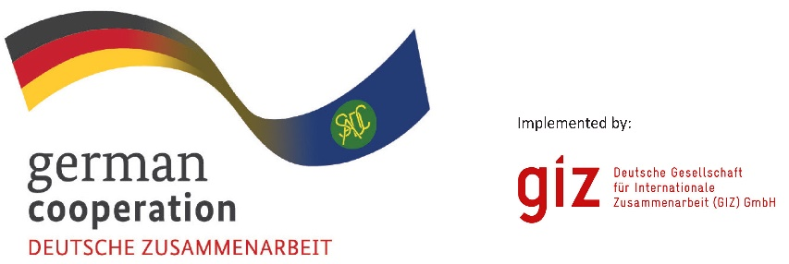

NOTICE
TENDER CANCELLATION
Notice is hereby given to all bidders of the cancellation of:

TENDER NO:
83483086 08/02/2025

TENDER DESCRIPTION:

Expression of Interest: Leather Value Chain Mapping Study & Facilitation of B2B Workshop

REASON FOR CANCELLATION
Change of Project scope

