

Link for Downloading Complete Tender Documents

For

PROPOSED SADC STANDBY FORCE REGIONAL LOGISTICS DEPOT AT RASESA, BOTSWANA, TO ATTAIN INITIAL OPERATING CAPABILITY

Tender No.: SADC/3/5/1/87

Issued on: 4th DECEMBER 2023

Link: https://collab.sadc.int/s/zQbk5meSGen6LAs

See below for Instructions for downloading the documents

Instructions for downloading tender documents

- Click the link provided above or copy link and paste in address bar of any web browser and hit ‘Enter’
- The following window will open:-

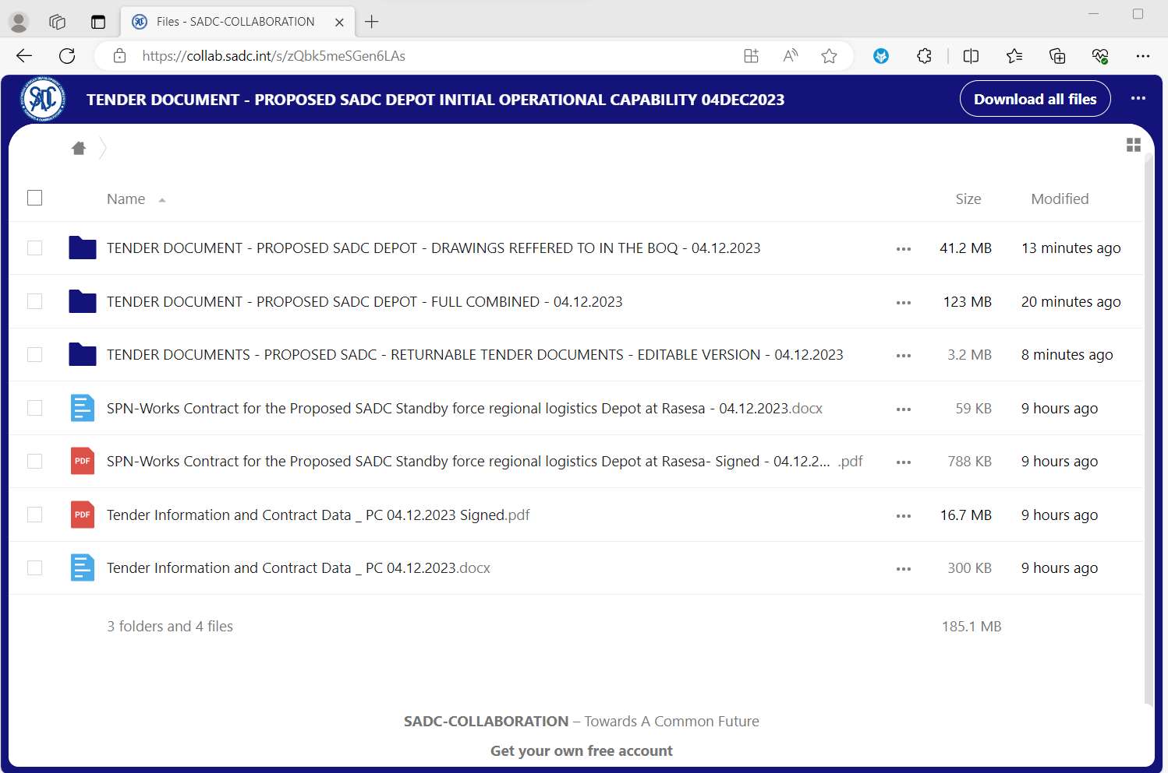

- Right Click on each document or folder and click on the word ‘Download’ that pops up as per below:-
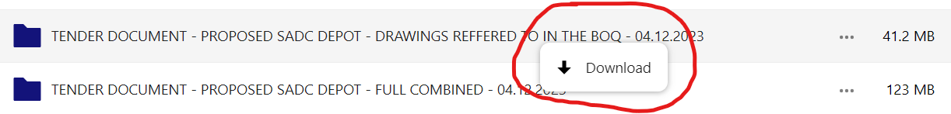
- Repeat the same for each document or folder until you download all documents.

- End -

