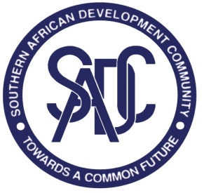
SADC SECRETARIAT RESPONSES TO REQUESTS FOR CLARIFICATIONS
REFERENCE NUMBER: SADC/3/5/4/70
CONTRACT TITLE: SUPPLY AND DELIVERY OF MICROSOFT LICENSES FOR THE SADC SECRETARIAT
DATE OF ISSUE OF RESPONSES: 27th June 2023

Q No. | Question | Response provided by SADC Secretariat
1 | Kindly Clarify, if you want NEW Microsoft Licenses Or RENEWALS? | RENEWAL. We have 300 licenses; however, we are in the process of acquiring 244 new license for two months. These will be renewed together with the current 300 licenses, making a total of 544 license for M365 E3. Hence the quantity is 544.
2 | I would like to enquire whether the reference SADC/3/5/4/70 bid is only subjected to companies in Botswana or open to SADC neighboring countries? | The tender is open to all bidders from all over the world.

End of Responses
Southern African Development Community
CBD Plot 54385
Phone: (267) 395 1863 | Fax: (267) 397-2 848

