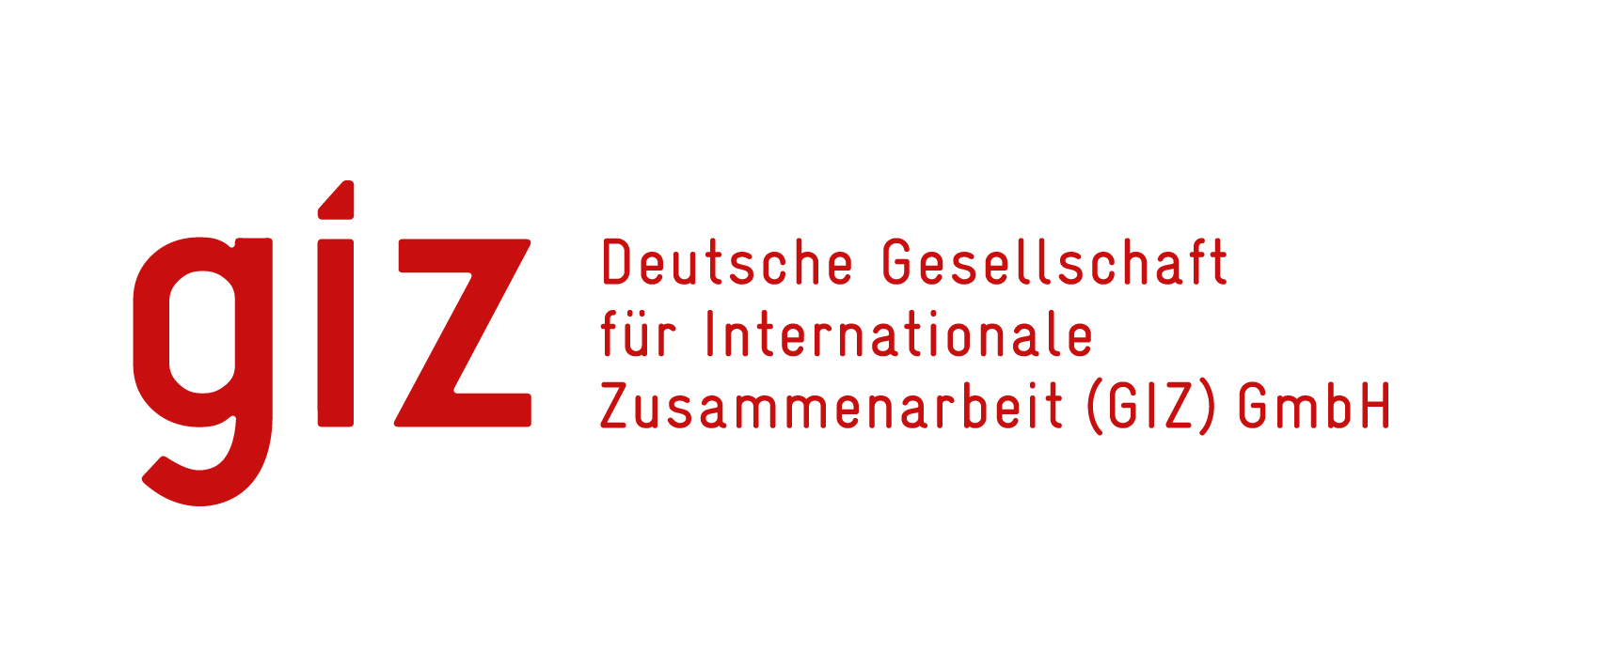
CALL FOR EXPRESSION OF INTEREST
Architectural Services

The EU and the SADC Secretariat have identified the Deutsche Gesellschaft für Internationale Zusammenarbeit (GIZ) GmbH as the lead implementing agency for the Results 2 and 3 of the SIPS Program (in the framework of a co-financed Contribution Agreement). GIZ is implementing the private sector component through a Multi-Donor Action, the Joint Action SIPS, jointly co-financed by the European Union and the Federal Republic of Germany's Federal Ministry for Economic Cooperation and Development (BMZ). In addition, GIZ implements the Private Sector Component of SIPS as part of the BMZ-commissioned program "Cooperation for the Enhancement of SADC Regional Economic Integration" (CESARE II) which has an implementation period of up to 41 months, with effect from October 2019.

GIZ intends to hire an Architect /Architectural firm to design and produce all necessary working drawings, construction budget and timelines to be used by the building contractor for the successful implementation of project construction of laboratory facilities for the University of Zambia, Department of Pharmacy at the Ridgeway Campus. The anticipated contract term from 15 February 2023 to 31st October 2023 (subject to extension) and the assignment will take place in Lusaka, Zambia.

The Architectural firm or bidder will perform its task and specifically undertake:
- Basic investigation and cooperation in obtaining the necessary data for the preparation of the preliminary design through analysis of the local site conditions
- Ensure specific expertise on laboratory design and construction is available for the architectural firm or bidder, e.g. by acquire/ hiring additional external experts
- Architectural design of the laboratory facilities considering laboratory workflows, inputs (gas, deliveries), outputs (waste, incineration), air locks, negative or positive pressure etc.
- Design of structural foundations and concrete structures, and reinforcement detailing.
- Preparation of service drawings: Electrical, Fire protection systems, Plumbing and HVAC drawings, specific services for laboratory usage, e.g. water and gas supplies, emergency (eye) showers, exhaust vents etc.
- Preparation of the bill of quantities documents,
- Preparation of specification documents arising from the materials incorporated in the design
- Prepare project budgets and project timelines taking into account GIZ internal processes
- Implementation of the design during construction as part of quality assurance.
- Assist in obtaining building permission and other permits required for the execution of the works arising from the materials incorporated in the design,
- Support tendering processes, if instructed to do so by the Joint Action SIPS Team
- Certify works done by contractor after works have been done in accordance with contract specification and acceptable workmanship. The quality and standards of materials and workmanship should fully satisfy the contract document,
- Preparation of reports required by the Joint Action SIPS team including Monitoring and evaluation reports for the contract implementation
- Acceptance of work after satisfying the quality and standards of materials and workmanship fully specified in the contract document have been applied after the end of the rectification period; of any works that was rejected. The final acceptance certificate is to be issued to the contractor for handing over of the works
- Preparation of final account for the Contractor, which require the complete measurement of the works after expiry of defects liability period and ratification of rejected works is completed. The final certificate should be made after deduction of the total amount of interim certificates and any advance payments,
- Evaluating of costs and benefits of different energy sources, with a provision for energy suitability consumption by providing back up facilities such as Generator set or Solar system

Important Information to Bidders:

- Must be fully registered with EIZ and ZIA.
- Must be able to show past experiences of minimum three projects of similar assignment.

Interested parties wishing to participate in the tender process can request for detailed Tender Documents by sending an email enquiry with the subject matter: “Call for Expression of Interest, Ref Architectural Services No. 83428550” to: zm_quotation@giz.de latest by Friday 13th January 2023 at 16:00hrs local time.

Note: enquiries received after the above stated deadline date and time will not be considered: responses will only be shared after closing date.

GIZ Procurement Unit

