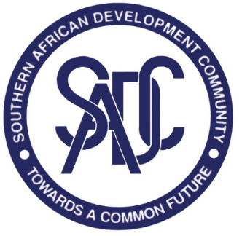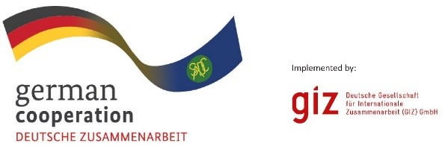

CONSULTANCY ADVERT contract 83411418
The German International Cooperation (GIZ) supports the Food, Agriculture and Natural Resources (FANR) Directorate of the Southern African Development Community (SADC) in the implementation of SADC protocols as well as development and implementation of strategies and programmes for biodiversity and natural resource management through the SADC/GIZ Project Climate Resilience and Management of Natural Resources in the SADC Region (C-NRM).
The C-NRM Programme strengthens the strategic planning framework for integrating climate change into transboundary natural resource management, supports the dissemination of knowledge on climate-smart agriculture and climate-sensitive natural resource management, promotes the recovery of the tourism sector in Transfrontier Conservation Areas (TFCAs) from COVID-19 effects and implements models of adaptation and mitigation with rural communities in selected TFCAs.
In 2021, the Ministers responsible for Environment, Natural Resources and Tourism endorsed and Concept Note that called for the Review of the SADC TFCA Programme (2013) after a need was identified to reflect on learnings and current needs. It is against this backdrop, that the SADC/GIZ C-NRM Programme is looking for a company to lead on the revision of the SADC TFCA Programme and accompanying documents. The selected service provider will enter into a contract with GIZ.
Bids, comprising of the (i) a technical offer and (ii) price offer, must be submitted as two separate attachments via email to BW_Quotation@giz.de by Friday 1 July, 16:00 hrs. CAT. Please carefully read the attached Invitation letter to Bid and Terms of Reference if you are interested to apply.

