

NEGOTIATED PROCEDURE
REQUEST FOR BIDS (RFB)

Reference Number: SADC/3/5/4/24

RFB Title: PROCUREMENT OF SADC ELECTION OBSERVATION MISSION (SEOM) REGALIA AND COVID-19 PERSONAL PROTECTIVE EQUIPMENT (PPE)

SADC Secretariat is inviting companies to submit a bids for the Supply of the following :

Requirement: One bidder must quote for all items listed below and failure to quote for all items will lead to the disqualification of the submitted bid . Bidders who fail to quote for all the requested items will disqualified.
- Bidders are expected to strictly comply with the following requirements when quoting for all SEOM items (jackets, golf-shirts, caps, back packs, first aid kits and the water bottles):
- Accurately quote for exactly the same material as shown in the description and specification in Table 1 Alternative quotes are not allowed;

- Accurately quote for exactly the same COVID-19 PPEs as shown in the description and specification in Table 1 However, surgical masks can either be sky-blue, navy-blue or royal blue in colour.

Table 1 Specifications for Layout, Design and Printing

Item | Description and Specification | Size/Description |  | Quantity | Compliance (YES/NO) | Comments
SEOM REGALIA
1. | Navy Blue (US Basic or equivalent) winter softshell jacket, for men and women, jackets with White Stripes on both sides, 280 g/m², 100% polyester interlock fabric bonded with 100% polyester mesh wind placket, two hand pockets with zips, two interior pockets, elastic cords with stoppers in back of collar and bottom hem, windproof 3000, moisture vapour proof 800 reflective piping on front and back, embroidery with SADC logo in full colour and 60mm diameter (on the left chest) and Arial font text embroidery of SADC ELECTION OBSERVER (on the back in white colour); SADC text on top flashing with, ELECTION OBSERVER text below (second row), measuring 200mm wide (length) and 130.7 high (height)  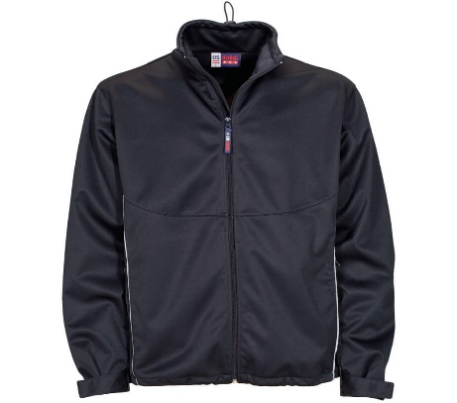 | Female  M = 10  L = 40  XL = 20  2XL = 20  3XL = 10 | Male  M = 50  L = 100  XL = 100  2XL = 90  3XL = 10 | 500
2. | Navy Blue (US Basic or equivalent) winter softshell jacket, for men and women, sleeveless jackets with White Stripes on both sides, 280 g/m², 100% polyester interlock fabric bonded with 100% polyester mesh wind placket, two hand pockets with zips, two interior pockets, elastic cords with stoppers in back of collar and bottom hem, windproof 3000, moisture vapour proof 800 reflective piping on front and back, embroidery with SADC logo in full colour and 60mm diameter (on the left chest) and Arial font text embroidery of SADC ELECTION OBSERVER (on the back in white colour); SADC text on top flashing with, ELECTION OBSERVER text below (second row), measuring 200mm wide (length) and 130.7 high (height)  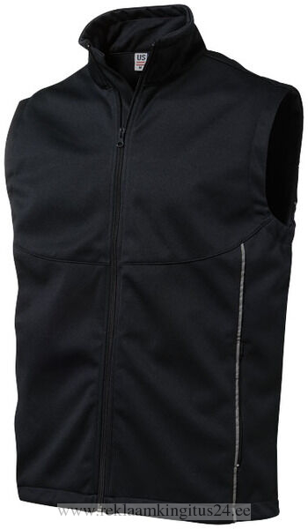 | Female  M = 10  L = 40  XL = 20  2XL = 20  3XL = 10 | Male  M = 50  L = 100  XL = 100  2XL = 90  3XL = 10 | 500
3. | Royal Blue (US Basic or equivalent) winter softshell jacket, for men and women, sleeveless jackets with White Stripes on both sides, 280 g/m², 100% polyester interlock fabric bonded with 100% polyester mesh wind placket, two hand pockets with zips, two interior pockets, elastic cords with stoppers in back of collar and bottom hem, windproof 3000, moisture vapour proof 800 reflective piping on front and back, embroidery with SADC logo in full colour and 60mm diameter (on the left chest) and Arial font text embroidery of SADC ELECTION OBSERVER (on the back in white colour); SADC text on top flashing with, ELECTION OBSERVER text below (second row), measuring 200mm wide (length) and 130.7 high (height)  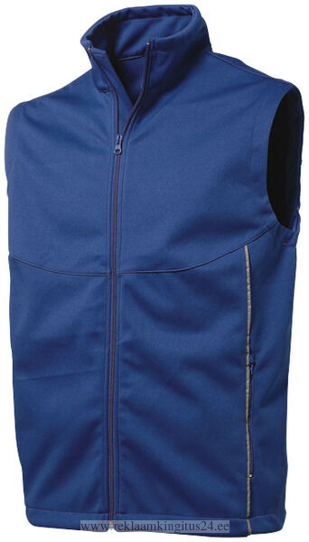 | Female  M = 10  L = 40  XL = 20  2XL = 20  3XL = 10 | Male  M = 50  L = 100  XL = 100  2XL = 90  3XL = 10 | 500
4. | White Matrix Golfer, for men and women, Squared collar styling with coordinated knitted collar and cuffs, Double-needle, top-stitch hem finish, Single top-stitching on armholes , Sporty style for ladies and men shaped, fit with side slits, Self-fabric neck tape, 190g Baron Polyester 65% and 35% Cotton fabric, embroidery with SADC logo in full colour and 60mm diameter (on the left chest) and Arial font text embroidery of SADC ELECTION OBSERVER (on the back in navy blue colour); SADC text on top flashing with, ELECTION OBSERVER text below (second row), measuring 200mm wide (length) and 130.7 high (height)  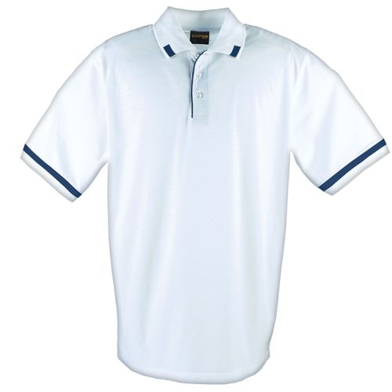 | Female  M = 10  L = 40  XL = 20  2XL = 20  3XL = 10 | Male  M = 50  L = 100  XL = 100  2XL = 90  3XL = 10 | 500
5. | Navy Blue Matrix Golfer, for men and women, Squared collar styling with coordinated knitted collar and cuffs, Double-needle, top-stitch hem finish, Single top-stitching on armholes , Sporty style for ladies and men shaped, fit with side slits, Self-fabric neck tape, 190g Baron Polyester 65% and 35% Cotton fabric, embroidery with SADC logo in full colour and 60mm diameter (on the left chest), and Arial font text embroidery of SADC ELECTION OBSERVER (on the back in white colour); SADC text on top flashing with, ELECTION OBSERVER text below (second row), measuring 200mm wide (length) and 130.7 high (height)  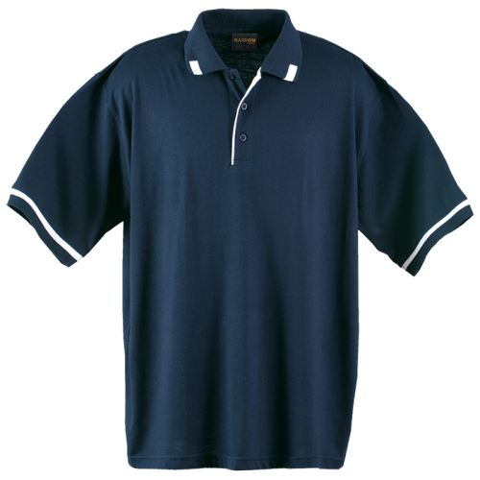 | Female  M = 10  L = 40  XL = 20  2XL = 20  3XL = 10 | Male  M = 50  L = 100  XL = 100  2XL = 90  3XL = 10 | 500
6. | Royal Blue Matrix Golfer, for men and women, Squared collar styling with coordinated knitted collar and cuffs, Double-needle, top-stitch hem finish, Single top-stitching on armholes , Sporty style for ladies and men shaped, fit with side slits, Self-fabric neck tape, 190g Baron Polyester 65% and 35% Cotton fabric, embroidery with SADC logo in full colour and 60mm diameter (on the left chest), and Arial font text embroidery of SADC ELECTION OBSERVER (on the back in white colour); SADC text on top flashing with, ELECTION OBSERVER text below (second row), measuring 200mm wide (length) and 130.7 high (height)  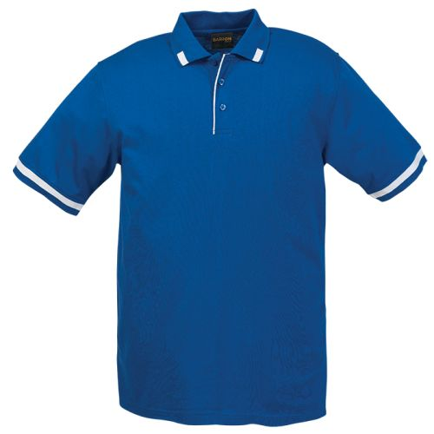 | Female  M = 10  L = 40  XL = 20  2XL = 20  3XL = 10 | Male  M = 50  L = 100  XL = 100  2XL = 90  3XL = 10 | 500
7. | Navy Blue Cap with white stripes, weight: 255g/m2, fabric: 100% heavy brushed cotton, 6-panel single contrast sandwich peak, 6 rows of stitching, 6 embroidered eyelets, self-fabric velcro closure, embroidery with SADC logo in full colour and 60mm diameter (in front).  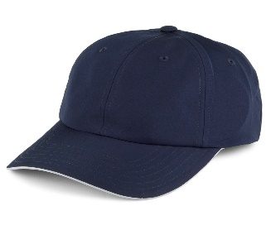 | One Size Fits All | 500
8. | Navy Blue or Royal Blue First Aid Kit; with all below items supplied in a portable carry pouch, domestic/ motorist kits, all in one packet containing the following; 2x first aid dressing No 2, 2x first aid dressing No 3, 1 x first aid dressing No 5, 2 x conform bandage 75mm, triangular bandages, 1 x Plasters (10’s), 1 x pack of sterile gauze swabs, 1 x surgical gloves, 1 x eye bath, 1 x eye drops (5ml), 1 x eye pad, 1 x paracetamol tablets (20’s), 1 x ENO satchets, 2 x antiseptic wound cleaner satchet, 1 x 20x20 cm sterile dressing, 1 x 10x10cm sterile dressing, 1 x antiseptic ointment, 1 x CPR (mouth to mouth device), 1 x safety pins (12’s), 1 x scissors, 1 x forceps (tweezers), 1 x surgical paper tape 24 x 3, the pouch should be branded with the screen printed SADC logo in one (1) colour (white) and 80mm diameter on the centre surface.  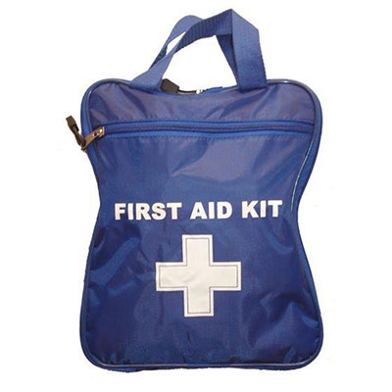 |  |  | 400
9. | Navy Blue (JanSport or equivalent) backpack with multiple pockets, large backpacks for utility usage, plain and simple, ergonomic s-curve shoulder straps, front utility pocket with organizer, fully padded back panel, pleated front stash pocket, side water bottle pocket, two large main compartments, web haul handle, zippered front stash pocket, screen printed SADC logo in full colour and 80mm diameter at the back lower pocket.  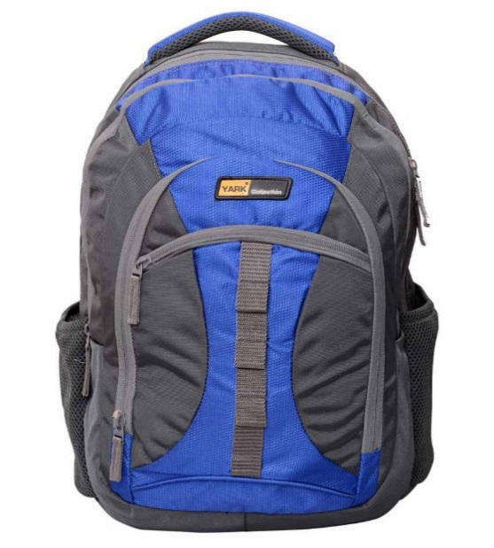 |  |  | 500
10. | 750ml Navy Blue Plastic Water Bottle with solid coloured tritan bottle with straw, Material: Tritan Plastic, Size: 7.5cm x 24cm x 8.5cm, Capacity: 750ml, durable tritan plastic drinking bottle, features a coloured bottle with a flip-up drinking spout in a matching colour, with a black screw-on lid with an integrated carry handle, screen wrap branded SADC logo in one (1) colour (white) and 50mm diameter on the centre body of the bottle on one side.  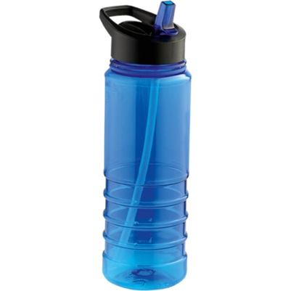 |  |  | 500
COVID-19 PPEs
11. | Disposable Surgical Mask, latex free, fiber glass free, hypo-allergic, with ear loops and nose piece, Box of 50 (per box), procedure / face masks, Hypoallergenic, Fiberglass fee, Fluid Resistant, Three Ply construction, 3 pleats of folds to allow the user to expand the mask so it covers the area from the nose to the chin, mask should be secured with an ear loop to be placed behind the ears, >99% Bacterial Filtration Efficiency (BFE) at 5 micron capacity; >95% Bacteria Filtra- tion Efficiency (BFE) at 3 micron capacity, the box packaging and/or masks do not require branding of the SADC logo.  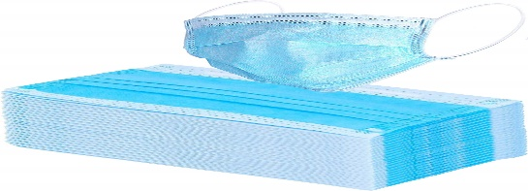 | The masks must be 1000 in number. They can be either Sky Blue or Black |  | 1000

Note the following:

- All above goods must be brand new and supplied in good condition and has not reached or is not nearing its end of use or expiry date.

- SADC branding materials (logo and its pantone colours) can be accessed from the SADC website; https://www.sadc.int/media-centre/logos-corporate-identity/

- The SADC logo always carries a white outline/ boundary line when applied into the items.

- Service providers are required to present a design mock-up on A4 papers in colour (for the following items; 1, 2, 3, 4, 5, 6, 7, 9 and10 of how the final product would look like. In addition, service providers are also to provide design mock-ups for back views for SEOM regalia (items # 1, 2,3, 4, 5 and 6). NB: Samples can either be for male or female provided all items which requires a sample has an artwork.

- Bidders who do not provide acurate design mock-ups of final products for the items above stated will automatically be disqualified.

- You should send only one quotation for this requirement.

- Your quotation should be addressed to this email: seomregalia@sadc.int.

- For any additional information and/or clarification please direct the inquiries to: yphillip@sadc.int; tenders@sadc.int; senthufhel@sadc.int. Copy: pchifani@sadc.int; kmonare@sadc.int; mmafiri@sadc.int ; lmpho@sadc.int;

- Quotations addressed to any other email recipients will not be considered.
5 The deadline for submission of your quotation to the email addresse indicated in Paragraph 2 above is: 10th June 2022; 15:00hrs bids submitted after the closing date and time will be rejected.

6. Your quotation should be submitted as per the following instructions, and in accordance with the Terms and Conditions of the Standard Purchase Order for SADC which is available on request.

(i) PRICES: The prices should be convertible to the local Pula currency (Include exchange rate to Pula if using foreign currency), including all duties attached to the sale of the goods (such as VAT, customs duties, etc.) and transport to the final destination.

- EVALUATION AND AWARD OF PURCHASE ORDER: Quotes determined to be administrative (see Paragraph 1,2,3,4,5,6,7,8 and 9) technically compliant to the requirements will be evaluated by comparison of their prices. The award will be made to the bidder offering an administratively and technically compliant quotation at the lowest total price.

- Minimum of three references from the clients where similar goods have been supplied must be submitted. Bids submitted without the same shall be disqualified.

- VALIDITY OF THE OFFER: Your quotations should be valid for a period of 90 days from the date of deadline for submission of quotation indicated in Paragraph 5 above.

- Bidders should submit their Company Profile, Banking Details, Certificate of incorporation, Valid Trading Licence Certificate and Valid Tax Clearance Certificate.

- Indicate that all above goods are brand new, supplied in good condition and has not reached or is not nearing its end of use or expiry date.

7. The Delivery period should be stipulated in the quotation. Goods must be delivered within 14 days from date of issue of purchase order or contract.

8. The deadline for receipt of requests for clarifications is 30th May 2022 at 15:30hrs.
The deadline for responses to the requests for clarification shall be 3rd June 2022 at 16:30hrs.
Goods have to be delivered within 14 days from the date of receipt of the purchase order by the bidder.



Bidders are required to quote for all items.

Finacial proposal Template

QTY | Description | Unit Price | Total
Subtotal
VAT
Total

Once corrections or adjustments have been applied, the Financial Proposal shall be adjusted with the Regional Preference if applicable.

The Procuring Entity shall grant a margin of preference in the evaluation of bids from companies from the SADC region when compared to bids from elsewhere. The margin of Prefence shall be calculated as a Maximum fifteen percent (15%) discount to the evaluated total price. In case of a Consortium, the quality for the regional and the companies providing at least 50% of the goods offered must be from the Region.

The final Selection for the provision of based on the lowest quoted price per lot. This selection will be from those who would have passed the Technical Stage.

