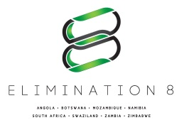
REQUEST FOR PROPOSALS

RFP No: E8-TTT-003-2016

RFP Title: Installation and Implementation of Health Service Posts for Expanded Access to Malaria Diagnosis, Treatment, and Surveillance for Mobile and Underserved Populations in the Angola-Namibia Border Areas of Southern Africa

Border Areas Included in the Award: Angola - Namibia

MODIFICATION 4

C. Proposal Submission Deadline Extension:

The deadline for submission of proposals has been extended. All proposals are expected at E8S Secretariat before or on January 23, 2017, 10:00 hours Central African Time. All proposals should be physically submitted to the E8 Secretariat at the following office address: Channel Life Towers, 1st floor, 39 Post Street Mall, Windhoek, Namibia. First Floor.

D. Bid Opening Extension

Proposals will be opened on January 23, 2017 at 14:00 hours Central African Time in the presence of bidders’ representatives who choose to attend in person. The venue of the Bid Opening will be: E8 Secretariat Conference Room, Channel Life Towers, 1st floor, 39 Post Street Mall, Windhoek, Namibia. First Floor. Late submissions will be rejected.

Modification Date: January 12, 2017

Procurement Department
Southern Africa Malaria Elimination Initiative (E8)
Channel Life Towers, 39 Post Mall Street
Cell: +264 81 159 7281 / +264 81162 5777
Email: procurement@elimination8.org
Windhoek, Namibia

