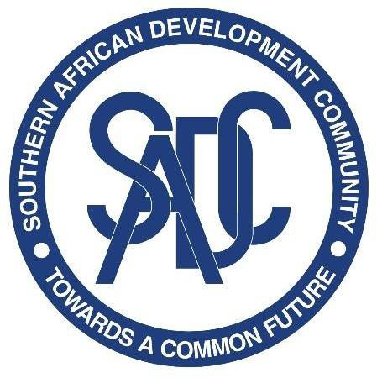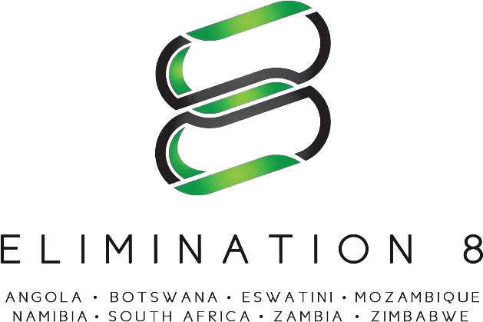

Terms of Reference for a Consultancy: Costing of the E8 Malaria Strategic Plan (2021 – 2025)

Overview
The SADC Malaria Elimination Eight Regional Initiative (E8) is a coalition of eight countries; Angola, Botswana, Eswatini, Mozambique, Namibia, South Africa, Zambia and Zimbabwe, working across national borders to eliminate malaria in the sub-region by 2030. The E8 was formed in 2009 and is led by the Ministers of Health in eight SADC countries with a mandate to plan, coordinate, and execute a regional malaria elimination strategy. As the malaria response arm of the Southern Africa Development Community (SADC), the E8 is pioneering an ambitious regional approach and driving collective action to end this deadly disease once and for all. Guided by the belief that countries are stronger when they work together, the E8 is building a model that will inform coordinated efforts in Southern Africa and beyond. Within the E8, member countries collaborate to address challenges that go beyond the scope or mandate of any one country, such as those associated with access to services for mobile and migrant populations, surveillance across connected malaria catchment areas in different countries, and pooling of specialized skills. The E8 Ministerial Committee is supported by a Technical Committee, and a Secretariat based in Windhoek, Namibia.

Vision, Goal and Strategic Objectives of the E8 Vision:
Vision: To have a malaria – free southern Africa
Goal: Maintain a joint platform for collaboration and strategic programming to enable and accelerate towards zero local transmission in the eight countries, with elimination in four frontline countries by 2025.

Strategic Objectives
Objective 1: Coordinate and Engage
To coordinate and engage E8 countries and stakeholders in achieving the regional elimination targets

Objective 2: Advocate and sustain
To maintain high political commitment to malaria elimination, ensure universal access to malaria

interventions, and ensure adequate, sustained technical and financial resources for malaria elimination

Objective 3: Harmonize, synchronize, and optimize
To harmonize, synchronize and optimize knowledge sharing and quality control, systems and policy development and implementation leading to elimination

Objectives of the Consultancy

A malaria strategic plan has been developed for the regional initiative detailing the strategic objectives and key performance areas for the years 2021 – 2025. As part of this strategic plan, an implementation and monitoring plan was developed. The main objective of the consultancy is to develop a detailed costing of the activities in the implementation plan of the strategy, to guide the region in the resources required to achieve its’ vision and goal.

Key deliverables:
The consultant is expected to deliver a detailed costing and budget of the E8 Malaria Strategy for 2021 – 2025
Key Performance area | Deliverable | Duration
Mapping of implementation areas by intervention | Cost inputs | 3 days
Market research on commodity and/or services pricing | Price list | 6 days
Populating budget template | Draft budget | 3 days
Budget summaries, cost groupings and instructions for use | Comprehensive budget | 3 days

Duration of Contract
15 days

Expected Profile of the Consultant
This consultant and/or their team are expected to possess the following skills:
  - Advanced degree with formal training in health economics, health systems, public health, health services research, biostatistics, or other related disciplines
  - At least five (05) years of experience in qualitative and quantitative market analysis, management, or strategic consulting in relevant field preferred
  - Advanced knowledge of market analysis concepts, analytical tools, and methods
  - Familiarity with regional programming and/or E8 country contexts.
  - Comparable experience in global health will be an added advantage
  - A high level of proficiency in oral and written English; knowledge of Portuguese is desirable.

How to Apply
Applications can be sent to procurement@sadce8.org on or before the 24th of November 2021.

