

REQUEST FOR BIDS (RFB)
Reference Number: SADC/3/5/1/21
Title: SUPPLY OF THE SADC BRANDED CLOTH MASKS
Number of Lots: 1
- SADC Secretariat is inviting reputable service providers to submit bids for the Supply of the SADC Branded Cloth Masks as follows:

# | Description
1. | - Fabric  The facemasks will be made of three fabric layers. The inner layer must be made of a good quality water absorbent fabric (100% good quality cotton), the middle layer must be a filter and the outer layer must be good quality water resistant fabric. The ear straps/ ear loops must be good quality thin elastic in black colour.  - Quantity  Requirement: 3140 SADC branded Cloth Facemasks  - Design  The facemask should cover the face from the bridge of the nose to under the chin. It should be loose fitting to enable easy breathing but still secure enough to stay in place. (Winning design will be based on the samples submitted to the SADC Secretariat).  - Colour - SADC Colours  Navy Blue – 1884 facemasks  Green – 628 facemasks  Gold – 628 facemasks  All ear straps/loops must be black.  - Branding  The SADC logo and flag will be embroidered on each side of the facemask branded with logo measuring 45mm diameter (right cheek), website www.sadc.int text measuring 45mm in length underneath the logo, and 45mm SADC flag (left cheek).  - SADC COLOURS:  Blue (Primary Colour) PANTONE Reflex Blue CVC HEX Code  Green (Primary Colour) PANTONE 354 CVC  HTML HEX Code  Gold (Primary Colour) PANTONE 11 C  HTML HEX Code  SADC branding materials (logo, pantone colours and flag can be accessed the website; https://www.sadc.int/media-centre/logos-corporate-identity/  NB: Service providers are required to submit one (1) sample facemask which replicates the final mask in Pantone Reflex Blue CVC HEX Code colour branded with logo measuring 45mm diameter (right cheek), website www.sadc.int text measuring 45mm in length underneath the logo, and 45mm SADC flag (left cheek), accompanied by three (3) mock-up artworks of the SADC facemasks (on A4 paper) in all 3 SADC colours for evaluation purposes. Only service providers submitting samples and mock-up designs shall be considered. All facemask samples should be submitted at the SADC Secretariat Head Office, Plot 54385 New CBD, Gaborone by the entrance (in a box labeled masks. (Indicate the name of the supplier on the sample/s).

- You should send only one bid for this requirement.
IMPORTANT: INCLUDE ALL RELEVANT DOCUMENTATION AS BELOW:
  - Certificate of Incorporation
  - Valid Trading License
  - Valid Tax Clearance Certificate
  - Valid VAT Certificate (where applicable)

- Your bid should be titled as shown below and addressed to:
“SUPPLY OF THE SADC BRANDED CLOTH MASKS".
Head – Procurement unit SADC Secretariat
Plot 54385 CBD
Gaborone BOTSWANA

Late submissions are not acceptable.

4. Bids should be emailed to the following email address: brandedmasks@sadc.int

Quotations by FAX will not be accepted.

5. The deadline for submission of your bids, to the addresses indicated in Paragraph 3 is: Wednesday 23rd October 2020; 15:30hrs.

6.Your bids should be submitted as per the following instructions, and in accordance with the Terms and Conditions of the Standard Purchase Order for SADC which is available on request.

  - PRICES: The prices should be quoted in local currency (PULA), including all taxes attached to the sale of the goods (such as VAT, customs duties, etc) and transport to the final destination which is the SADC Secretariat Headquarters, Gaborone, Botswana.

  - EVALUATION AND AWARD OF PURCHASE ORDER: Bids determined to be administrative (see Paragraph 2,3,4 and 5 and technically compliant to the requirements will be evaluated by comparison of their prices and samples as defined above. The award will be made to the bidder offering an administratively and technically compliant quotation at the lowest total price for the lot.

  - VALIDITY OF THE OFFER: Your Bid should be valid for a period of 90 days from the date of the deadline for submission of bids indicated in Paragraph 4 above.

  - DISCLAIMER: SADC will not be responsible for any costs nor expenses incurred in connection with the preparation or submission of bids.

- The Cloth Masks are expected to be delivered within 2weeks from the signature of the Purchase Order.

- Additional information and clarifications can be requested in writing, via the email addresses below no later than Wednesday 21st October 2020; 15.30hrs.
Email: brandedmasks@sadc.int cc: dshibnautha@sadc.int; cc: lmpho@sadc.int
during working hours.
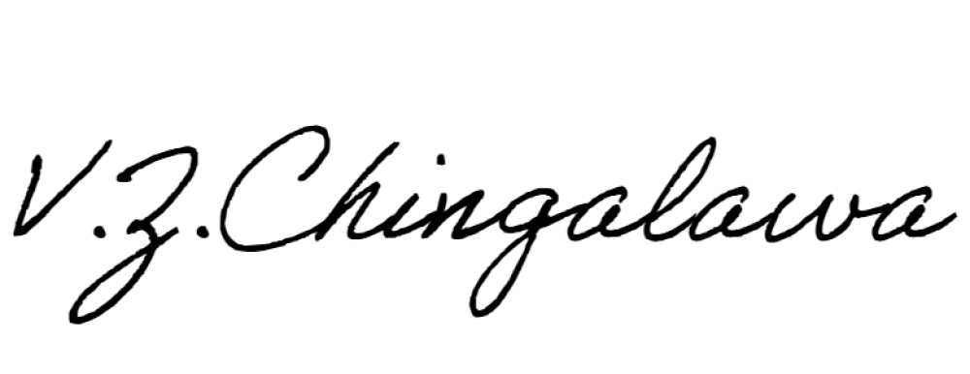
Sincerely,

Name: Mrs Veronica Chingalawa
Title: Acting Senior Officer - Procurement Date: 14th October 2020

ANNEX 1 TECHNICAL SPECIFICATIONS

# | Description | Qty | Unit  Price | Price
1. | Technical Specifications:  - Fabric  The facemasks will be made of three fabric layers. The inner layer must be made of a good quality water absorbent fabric (100% good quality cotton), the middle layer must be a filter and the outer layer must be good quality water resistant fabric. The ear straps/ ear loops must be good quality thin elastic in black colour.  - Quantity  Requirement: 3140 SADC branded Cloth Facemasks  - Design  The facemask should cover the face from the bridge of the nose to under the chin. It should be loose fitting to enable easy breathing but still secure enough to stay in place. (Winning design will be based on the samples submitted to the SADC Secretariat).  - Colour - SADC Colours  Navy Blue – 1884 facemasks  Green – 628 facemasks  Gold – 628 facemasks  All ear straps/loops must be black.  - Branding  The SADC logo and flag will be embroidered on each side of the facemask branded with logo measuring 45mm diameter (right cheek), website www.sadc.int text measuring 45mm in length underneath the logo, and 45mm SADC flag (left cheek).  - SADC COLOURS:  Blue (Primary Colour) PANTONE Reflex Blue CVC HEX Code  Green (Primary Colour) PANTONE 354 CVC  HTML HEX Code  Gold (Primary Colour) PANTONE 11 C  HTML HEX Code  SADC branding materials (logo, pantone colours and flag can be accessed the website; https://www.sadc.int/media-centre/logos-corporate-identity/  NB: Service providers are required to submit one (1) sample facemask which replicates the final mask in Pantone Reflex Blue CVC HEX Code colour branded with logo measuring 45mm diameter (right cheek), website www.sadc.int text measuring 45mm in length underneath the logo, and 45mm SADC flag (left cheek), accompanied by three (3) mock-up artworks of the SADC facemasks (on A4 paper) in all 3 SADC colours for evaluation purposes. Only service providers submitting samples and mock-up designs shall be considered. All facemask samples should be submitted at the SADC Secretariat Head Office, Plot 54385 New CBD, Gaborone by the entrance (in a box labeled masks. (Indicate the name of the supplier on the sample/s). | 3140

