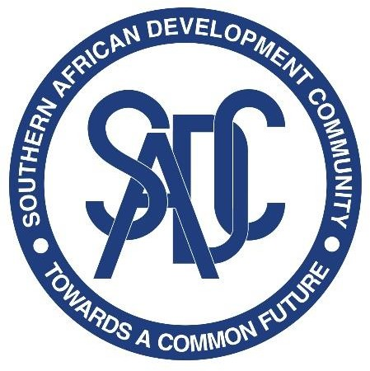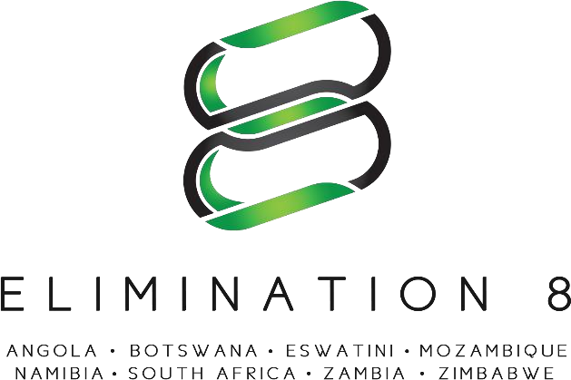

Terms of Reference for a Consultancy:
Malaria Matchbox Assessment (re-advertised)

Overview
The SADC Malaria Elimination Eight Initiative (E8) is a coalition of eight countries; Angola, Botswana, Eswatini, Mozambique, Namibia, South Africa, Zambia and Zimbabwe, working across national borders to eliminate malaria in the sub-region by 2030. The E8 was formed in 2009 and is led by the Ministers of Health in eight SADC countries with a mandate to plan, coordinate, and execute a regional malaria elimination strategy. As the malaria response arm of the Southern Africa Development Community (SADC), the E8 is pioneering an ambitious regional approach and driving collective action to end this deadly disease once and for all. Guided by the belief that countries are stronger when they work together, the E8 is building a model that will inform coordinated efforts in Southern Africa and beyond. Within the E8, member countries collaborate to address challenges that go beyond the scope or mandate of any one country, such as those associated with access to services for mobile and migrant populations, surveillance across connected malaria catchment areas in different countries, and pooling of specialized skills. The E8 Ministerial Committee is supported by a Technical Committee, and a Secretariat based in Windhoek, Namibia.
Vision, Goal and Strategic Objectives of the E8 Vision: To have a malaria – free southern Africa
Goal: To enable and accelerate zero local transmission in the four frontline countries by 2020 (and the second line countries by 2030) through the provision of a platform for collaboration and strategic programming.

Objectives of the Consultancy

Accelerated progress towards malaria elimination requires understanding how poverty, social norms, gender inequality, legal status and language barriers affect individuals and their ability to access and utilize prevention, diagnosis and treatment of malaria, as well as basic healthcare more broadly. Greater emphasis is also placed on understanding specific country contexts where programs are deployed and the characteristics of different population groups in need of healthcare services, to leave no one behind. To address these challenges, the Malaria Matchbox Toolkit has been designed to improve the capacity of malaria programs to make services available, accessible, and acceptable for all individuals at risk of malaria.
The main objective of this consultancy, therefore, is to:
Conduct an assessment using the Malaria Matchbox Toolkit to determine risk factors and barriers impeding equitable and integrated people-centered malaria programs; and provide recommendations on how to address them.
- Terms of Reference:
- Spearhead discussions during country engagement processes;
- Conduct situational analysis of malaria matchbox assessment plans in the E8 countries;
- Customize malaria matchbox assessment tool;
- Coordinate regional malaria matchbox assessment process;
- Develop assessment report and action work plan from recommendations.
- Key deliverables:
The consultant is expected to deliver:
- Overall project workplan
- Situational analysis report;
- Customized matchbox assessment tool;
- Assessment report including proposed actions and a regional (E8) work plan.
- Duration of Contract

The estimated period for completion of the work is up to 60 days spread over eight (8) months.

Expected Profile of the Consultant
This consultant and/or his team is expected to possess the following skills:
- Advanced degree in economic or social sciences, evaluation management or other related fields;
- At least five (05) years of relevant professional experience conducting socio-economic assessments; experience with matchbox assessments will be an asset;
- Comparable experience in global health will be an added advantage.
- Demonstrated good research, analytical and report writing skills including ability to establish rapport;
- Experienced working in the SADC region and familiarity with E8 malaria country programmes.
- A high level of proficiency in oral and written English; knowledge of Portuguese would be an advantage.

How to Apply
Applications can be sent to procurement@sadce8.org and copy to dshaba@sadce8.org and nshipiki@sadce8.org on or before the 30th of November 2021.

